San Antonio Mid-Year Check In Survey
To: Clinical Transition Unit Team
From: Melissa Harris, MSN, RN, NE-BC
Date: ASAP
Subject: We want to hear your voice in the Employee Engagement Mid-Year Check-In Survey!

Team,
I valued your participation in the Employee Engagement Survey Results meeting. Your input is important in shaping our department’s action plan to build a positive culture. In order to gauge the effectiveness of our communication in this ongoing process, I would like to ask you to complete a brief, anonymous survey. This survey should take no more than five minutes and it is very important that we receive a response from everyone on our team. Each of you is essential to the success of the entire department.
Here is the link to take the survey: https://www.surveymonkey.com/r/NYYSRYK
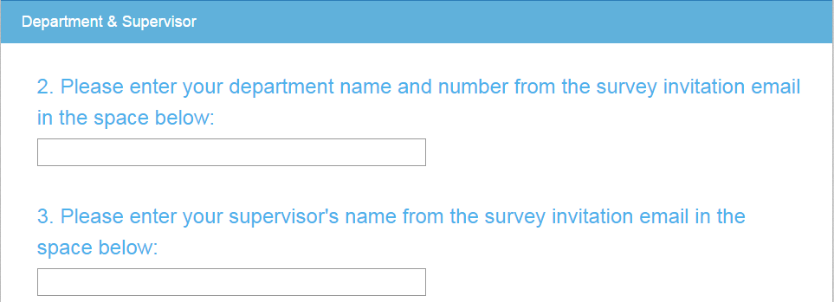
You will be asked to provide your department and supervisor name on page 3 of the survey. Please enter the following into the survey:
Department Name/Number: 740

Supervisor Name: Melissa Harris

Should you have any other questions regarding this survey or our department action plan, please do not hesitate to ask me.
Thank you,
Melissa Harris, MSN, RN, NE-BC

